Software Requirements specification

**Book Booth**

**Group members:**

Waqas Javed : 33784

Ali Ariz :

Hamna Asif : 34822

**Submitted to: Ma’am Mazil e Maqsood**

**Date: 31st Dec 2016**

# 

Table of Contents

1 Introduction 3

1.1 purpose 3

1.2 scope of project 3

2 Description 3

2.1 Product Perspective 3

2.2 User characteristics: 4

3 Requirements 4

3.1 Business Requirement 4

3.2 Functional Requirement 4

3.3 Nonfunctional Requirement 5

4 Use Case 6

4.1 Diagram 6

4.2 Use cases and Description: 7

5 Architecture 12

5.1 Diagram 12

5.2 DESCRIPTION: 13

# Introduction

## purpose

The purpose of this document is to give a detailed description of the requirements for the “Book Booth” website. It will illustrate the purpose and complete declaration for the  
development of the system.

## scope of project

The Book Booth is a website solution for sale/purchase of Old books. The website helps in connecting sellers to buyers .The aim of this project is to provide hard copy of the book at best price and let books easily available to all.

Seller and Buyer shall be connected through the website and then they can proceed the transaction by physically meeting or other methods they agreed on. The transfer of book and money shall be the responsibility of seller and buyer respectively.

# Description

This section will give an overview of the whole system. The system will be explained in its context to  
show how the system interacts with other systems and introduce the basic functionality of it. It will also  
describe what type of stakeholders that will use the system and what functionality is available for each  
type.

## Product Perspective

The system will consist of a web application which will have 3 main parts

1) Front-End

2) Back-End

3) Database

Front-End

Front-end will be a responsive design. Front end development will follow MVC. The user will interact with system via views which in response calls Controller function to perform the desired functionality. It will be the Controller Responsibility to ensure the data transaction from the server database to Models and server and communication with server.

Back-End

It will be the responsibility of Back-end to provide data to authorized user on front-end from database and serve all the clients.

Database

Database will provide the safe place to store and retrieve data as and when required.

## User characteristics:

There are three types of user that interact with the system .user selling the book, user buying the book and admin who controls the system. Seller shall upload details of the book and wait to be contacted. Buyer shall look for the book and contact the seller. Admin will restrict unauthorized users.

# Requirements

This section contains all the business, functional and quality requirements of the system.

## Business Requirement

|  |
| --- |
| 1) The system shall have 1000 registered user within 3 months. |
| 2) The system shall be distributed in 5 major universities of Islamabad. |
| 3) The system shall have 2000+ books in database by 3 months. |

## Functional Requirement

This section includes the requirements that specify all the fundamental actions of the software system.

|  |
| --- |
| 1).User shall be Able to Register into the System. |
| 2) User shall be able to maintain his /her profile. |
| 3) User shall be able to feed details of the book in to the system. |
| 4) User shall be able to view books he is selling. |
| 5) User shall be able to mark the books as sold. |
| 6) User shall be able to view nearby (Location wise) selling books. |
| 7) User shall be able to search a particular book. |
| 8) User shall be able to make friends with other users. |
| 9) User Shall be able to chat with other users. |
| 10) User shall be able to search nearby Friends. |
| 11) The admin shall be able to block any profile. |
| 12) The admin shall be able to delete any book. |
| 14) The admin shall be able to view any profile. |
| 15) User shall be able to register once with a single email. |

## Nonfunctional Requirement

|  |
| --- |
| 1) The System shall be runnable on Chrome. |
| 2) The system shall respond in under 2 seconds for 95 % of uses. |
| 3) The system shall restrict unauthorized users to change data. |
| 4) Database used shall be MySQL. |
| 5) The system shall be available 24/7. |
| 6) The system shall support 10,000 additional users added in the month. |

# Use Case

## Diagram

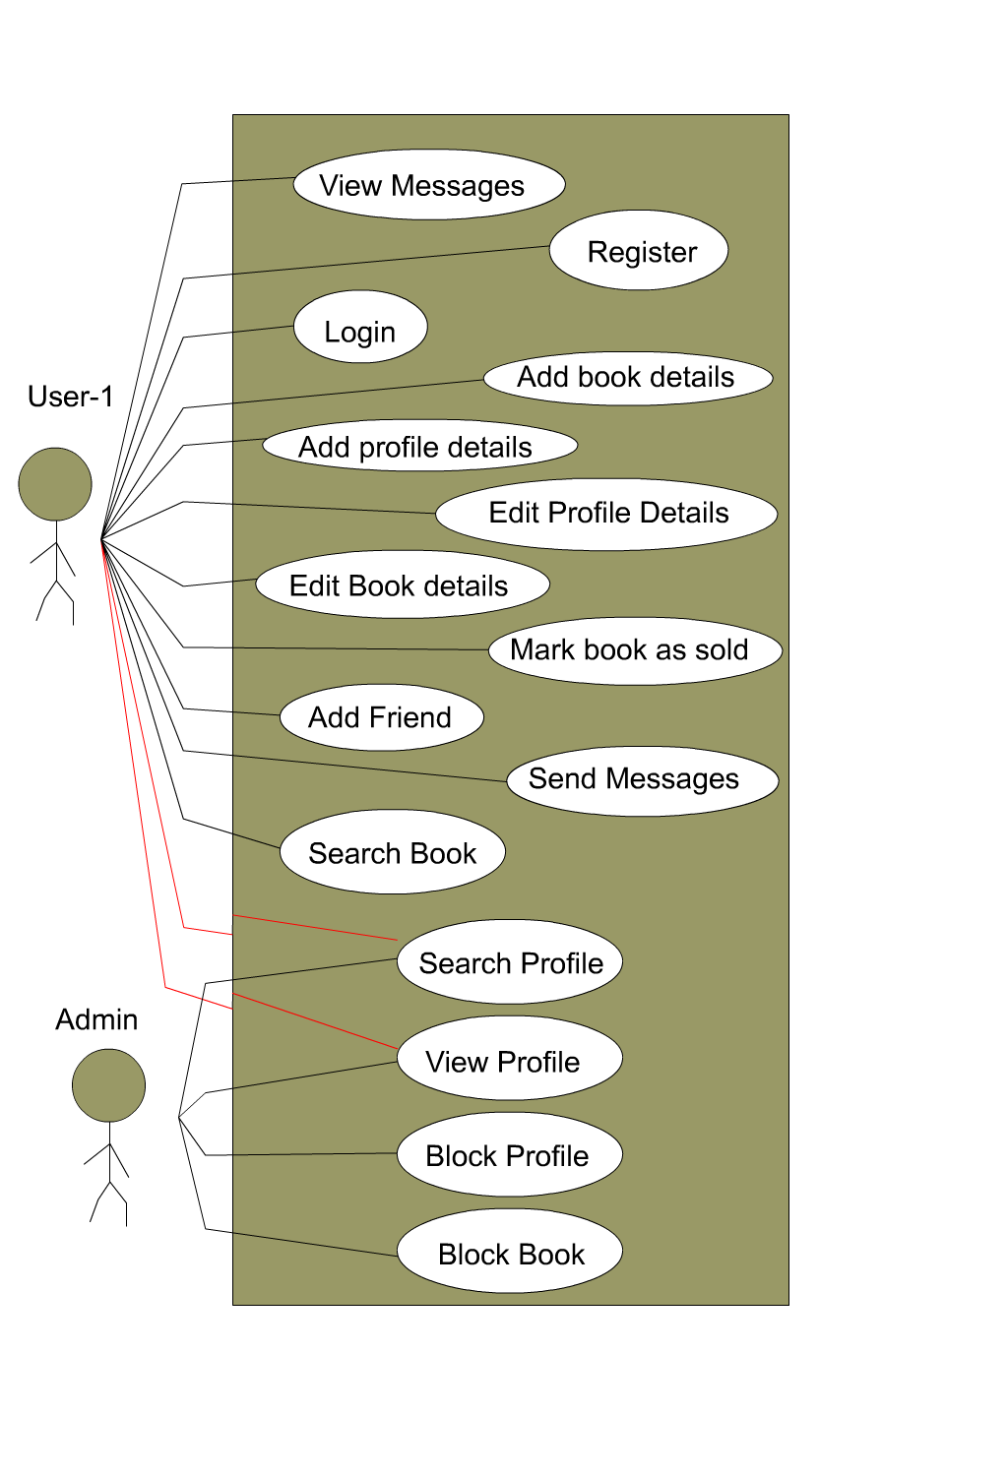

## Use cases and Description:

### Registration

Pre-Condition:

* + - User has opened User Registration Page
    - User enters all details correct

Steps:

* + - User enters first name, last name, email, password, confirm password
    - User press Register button

Post-Condition:

* + - User data is inserted in database.
    - User is redirected to Profile page.

### Login

Pre-Condition:

* + - User is already registered.
    - User enters all details correctly.

Steps:

* + - User enters email, password.
    - User presses login button.

Post-Condition:

* + - User gets authorized.
    - User redirected to its profile page.

### Add Book Details

Pre-Condition:

* User is logged in.

Steps:

* User enters information about book that are title, condition, price, author, edition, pictures.
* User presses add button.

Post-Condition:

* Book data is inserted in database.

### Add profile details

Pre-Condition:

* User is logged in.
* User has not submitted profile details previously.

Steps:

* + - User enters all details some of which are mandatory.
    - About(Mandatory): Gender, DOB,
    - Contact(Mandatory): phone-numbers, Address
    - Works(Optional): Occupation, Skills(Multiple), Education(Multiple), Experiences(Multiple)
    - User presses save button

Post-Condition

* User profile details are saved in database.

### Edit Profile Details.

Pre-condition:

* User is logged in:

Steps:

* User goes to his profile
* User press edit profile button
* User can update any field he wants.
* User press update button.

Post-Condition

* All details are updated in database.

### Edit Book Details.

Pre-condition:

* User is logged in

Steps:

* User goes to his profile
* User goes to books he is selling.
* User press edit book button.
* User can update any field he wants.
* User press update button.

Post-Condition

* All details of book are updated in database.

### **Mark Book as sold**

Pre-condition:

* User is logged in.

Steps:

* User goes to his profile.
* User goes to books he is selling.
* User press mark as sold button.

Post-Condition

* Book is marked as sold in database.

### Add friend

Pre-condition:

* User is logged in.

Steps:

* User goes to his profile.
* User search for people.
* User goes to profile of person he want to add as friend.
* User clicks on Add friend button.

Post-Condition

* Friend database table is updated.

### Send Message to friend

Pre-condition:

* User is logged in
* User has friend in his friend list

Steps:

* + - User goes to his profile.
    - User goes to chat page.
    - User clicks on create message.
    - User selects friend.
    - User writes message.
    - User presses send message.

Post-Condition

* Message is sent to friend (Updated in database).

### Search Book

Steps:

* User goes to search books page.
* Enter search criteria.
* Click on search.

Post-Condition:

* Details of all books available nearby will be shown.

### Search Profile

Pre-Condition:

* User/Admin is logged in.

Steps:

* User goes to search profile page.
* User enters search criteria.
* User press search.

Post-Condition:

* Profiles with matching criteria are shown.

### View Profile

Pre-condition:

* User profile exists on database.

Steps:

* User enters profile link of any existing user.

Post-Condition:

* The profile of person with link address is shown.

### Block Profile:

Pre-Condition:

* Logged in as admin.
* User profile Exists.
* Admin is on User profile page.

Steps:

* Admin click on Block Profile.

Post-Condition:

* User profile is not searchable any more.
* User can’t log in again.

### Block Profile:

Pre-Condition:

* + - Logged in as admin.
    - User profile Exists.
    - Book is added.
    - Admin is on User profile page.

Steps:

* Admin click on Books by user.
* Admin click on Block Book.

Post-Condition:

* + - Book is marked as blocked in database.
    - Book is not searchable.

### View Messages:

Pre-Condition:

* + - User have some messages sent by someone or by him.
    - User is logged in.

Steps:

* + - User goes to his profile.
    - User open chat module.
    - User Click on desired user messages.

Post Condition:

* All sent and received messages are shown to User.

# Architecture

## Diagram

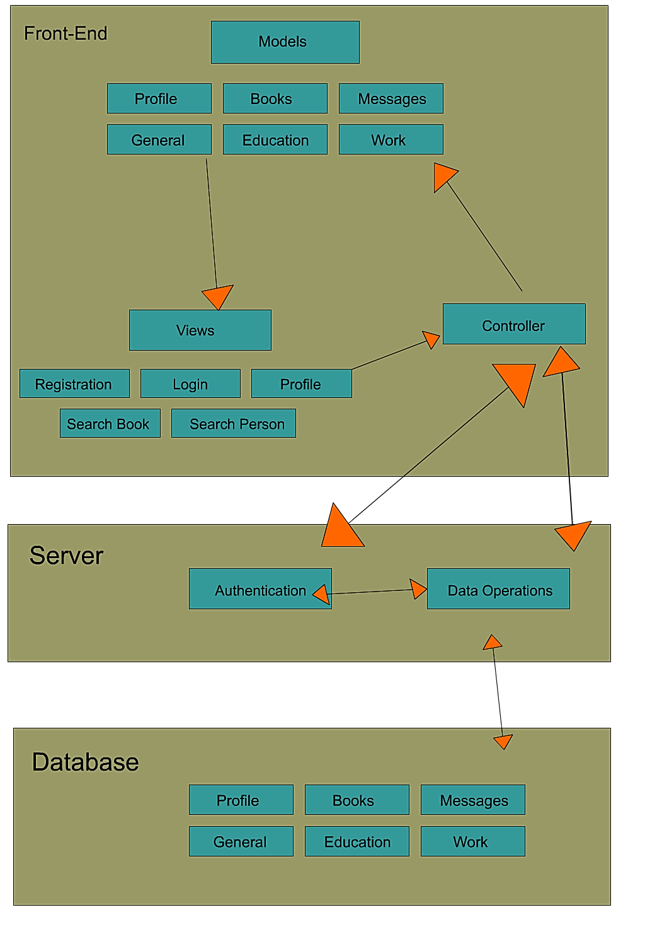

*Architecture diagram book boot*

## DESCRIPTION:

The system is using Client-Server Model.

The Client shall be built on MVC.

The model represents the data.

The view displays the model data and sends user action to the controller.

The Client controller shall interact with server.

The server shall interact with Client and Database and make their communication possible.

--------------------------------------